**Story**

|  |  |
| --- | --- |
| Date | 19 March 2025 |
| Team ID | LTVIP2025TMID19942 |
| Project Name | Cosmetic Insights : Navigating Cosmetics Trends and Consumer Insights with Tableau |
| Maximum Marks | 5 Marks |

By using stories in Tableau, you can effectively communicate complex data in a way that is both interactive and engaging, making it easier for the audience to follow along and understand the insights. It’s a tool for **data storytelling**, allowing you to present insights in a cohesive, engaging way that takes viewers through a logical progression of findings or analyses.

In Tableau, **Story** is a feature that allows you to create a sequence of dashboards, visualizations, and text to present data insights in a cohesive and narrative-driven way. It's like a slideshow within Tableau that guides the audience through a series of data points, helping them understand key insights, trends, or outcomes of your analysis.

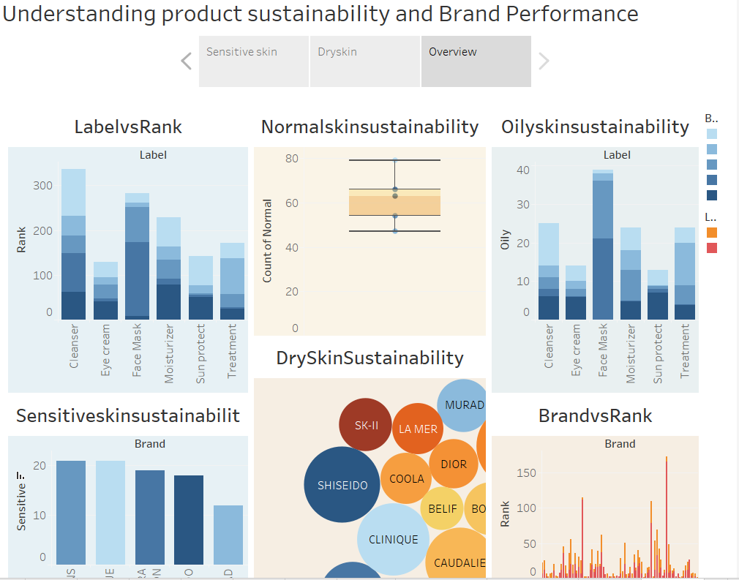

Observations:

* **Cleansers Lead in Label Rankings:** The LabelvsRank stacked bar chart shows that Cleansers have the highest ranking at around 350, indicating they are the most prominent product category in terms of label ranking.
* **Consistent Normal Skin Sustainability Scores:** The Normalskinsustainability box plot indicates that normal skin sustainability scores range from 50 to 80 with a median around 65, suggesting consistent performance across products for normal skin.
* **Face Masks Excel in Oily Skin Sustainability:** The Oilyskinsustainability stacked bar chart reveals that Face Masks have the highest count at around 40 for oily skin sustainability, making them the top category for addressing oily skin concerns.
* **Dr. Jart+ and First Aid Beauty Strong in Dry Skin Sustainability:** The DrySkinsustainability bubble chart highlights that Dr. Jart+ and First Aid Beauty have larger bubbles, indicating a stronger association with dry skin sustainability compared to other brands.
* **Origins and Clinique Top Sensitive Skin Sustainability:** The Sensitiveskinsustainability histogram shows that Origins and Clinique lead with scores around 21, making them the most suitable brands for sensitive skin, while Murad scores the lowest at around 12.